New Patient Form
First Name |  | Surname
Address |  | Town
 |  | Postcode
Home Ph | Work Ph |  | Mobile
Date of Birth |  | Email
Occupation |  | Marital Status
Type of work: Active/Sedentary Heavy/Light Hours of driving Other?
Children? |  | Referred by?
How did you hear about us?

Please give a brief description of your reason for visiting us, including severity and duration.
1.
2.
3.
Please mark all problem areas on this diagram.
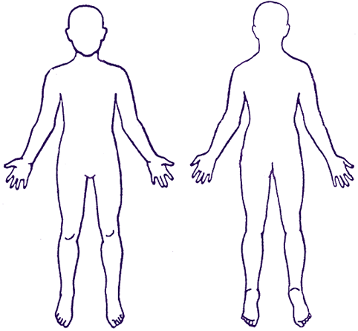
Please circle the terms below that best describes your pain.
Burning Dull Ache
Throbbing Numb Tingling
Progressively Worse Comes & Goes
Shooting Worst pain ever
Staying the same Getting better

What aggravates your condition?
What relieves your condition?
Have you ever had this type of pain before?
What do you think has caused your condition?
Please circle if you have had any of the following:
Frequent colds / infections/ Poor concentration /Headaches / Migraines / Arthritis/ Cold hands / feet Low energy fatigue/ Menstrual pain / Digestive problems /Bladder problems/ Hot flushes / fevers Heart disease/ Anxiety / Nervousness /Irritability /Allergies /Stroke/ Ulcers /Depression /Mood swings /Diabetes/ High blood pressure /Low pain threshold /Seizures / Fainting/ Respiratory problems/ Low back pain/ Neck pain/ Dizziness /Cancer

Have you ever been to a Chiropractor before? Yes No If yes, when? ______________________
Have you seen another therapist about your condition? If so who and what was the outcome?

Name and address of current GP: _________________________________________________
Date of last physical: ____ / ____ / ____
Please list any operations you have had (and ages):
1. _______________________ 2. ________________________ 3. ____________________
Please list any serious illnesses you have had (and ages):
1. _______________________ 2. ________________________ 3. ________________________
Please list any traumas, accidents, broken bones or injuries you have had (and ages):
1. _______________________ 2. ___________________ ___ 3. _________________________
Are you currently taking medication (including the contraceptive pill)? If yes, what type and what for?
_______________________________________________________________________________
Do you smoke? Yes No
If yes, how many per day? _______________ for how many years?____________
Do you drink? Units/week
Females Only: Is there any possibility that you are pregnant? Yes No
Date of last period: ___ / ___ / ____
Has any blood relative (not including your spouse) had any of the following. If yes, please specify (who, what, when):
Bone or Joint disease (Arthritis / Osteoporosis) ________________________________________
Vascular disease (Heart disease / Stroke / Blood Pressure) _______________________________
Cancer (Benign / Malignant) ____________________________________________________
Respiratory problems (Lung / Chest / Asthma) ________________________________________
Digestive problems (Stomach / Bowel) ______________________________________________
Reproductive problems __________________________________________________________
Diabetes / Metabolic disorders ___________________________________________________
Epilepsy / Nervous system disorders ________________________________________________
Skin disorders __________________________________________________________________
Allergies ______________________________________________________________________
Other ________________________________________________________________________

Please give a brief description of your eating habits.

Chiropractic examination and therapeutic procedures including but not limited to spinal adjustments, heat/ ice application, and manual muscle therapy are considered safe and effective methods of care. Any procedure intended to help may have complications. While the chances of experiencing complications are small it is the practice of this clinic to inform our patients about them. These complications include, but are not limited to, soreness, inflammation, soft tissue injury, dizziness, burns, and temporary worsening of symptoms. More serious complications are extremely rare. Additional information on side-effects and complications is available upon request.
I have read and understand the above statements regarding treatment side effects. I also understand that there is no guarantee or warranty for a specific cure or result.

DECLARATION: This information is accurate to the best of my knowledge.
PATIENT…………………………………………SIGNATURE: .............................................. DATE: ….../……/……
CHIROPRACTOR SIGNATURE: ………………………………………………….... DATE: …../……/…….

